1. **SQL SERVER**

To download Sql server go to: <https://www.microsoft.com/en-us/sql-server/sql-server-downloads>

Choose Developer version:

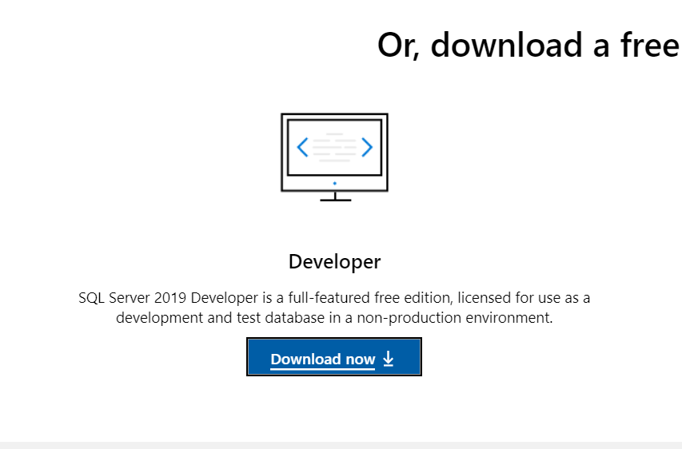

Download and Run installation package **SQL2019-SSEI-Dev.exe** (it will download installation files on your PC and start installation)

Choose :

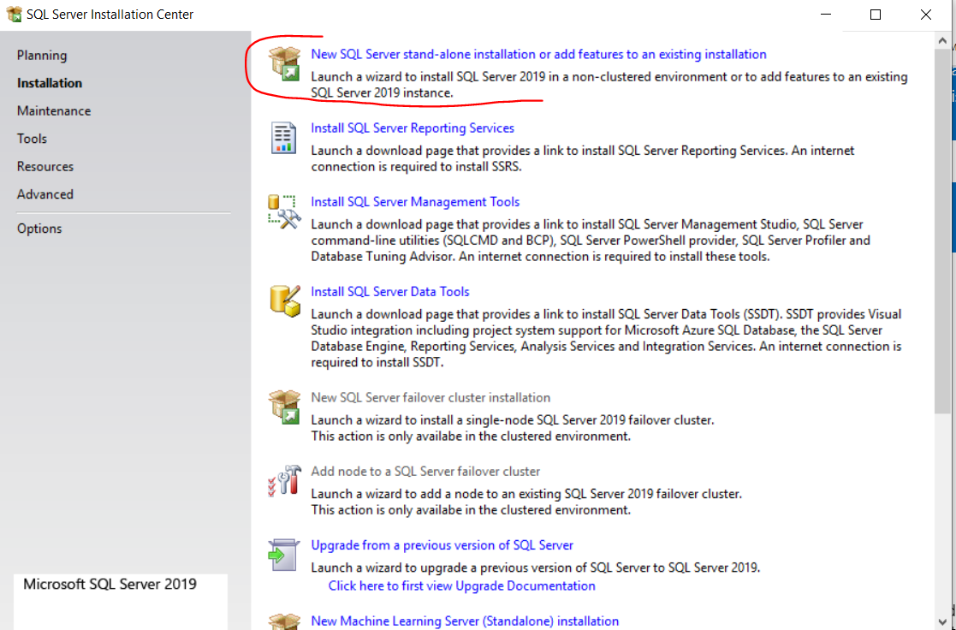

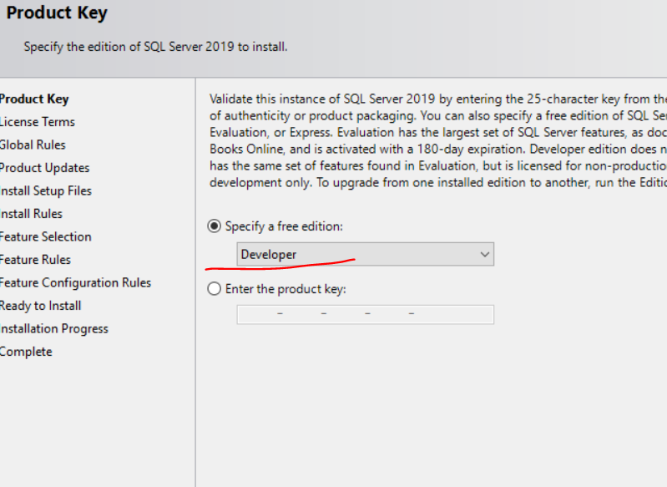

Chose list of features to be installed and don’t change directories by default:

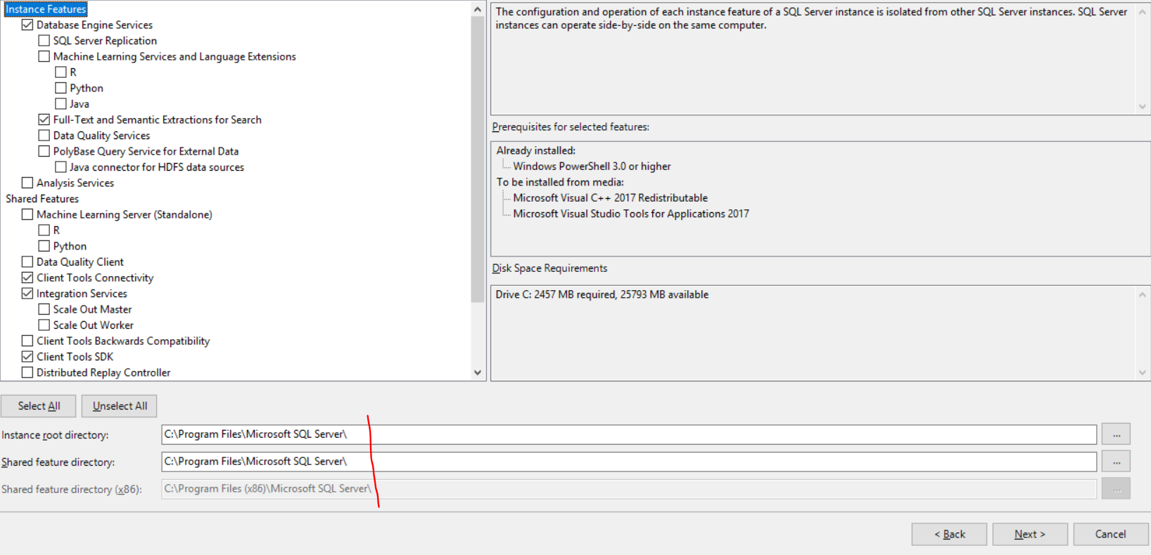

next steps by default:

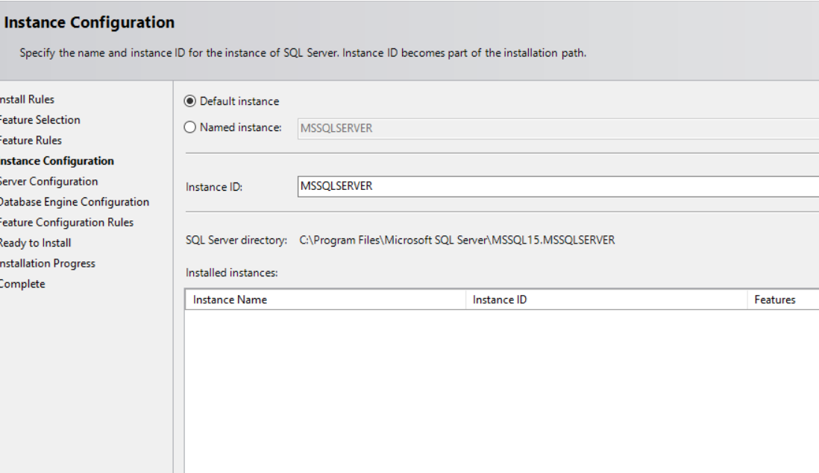

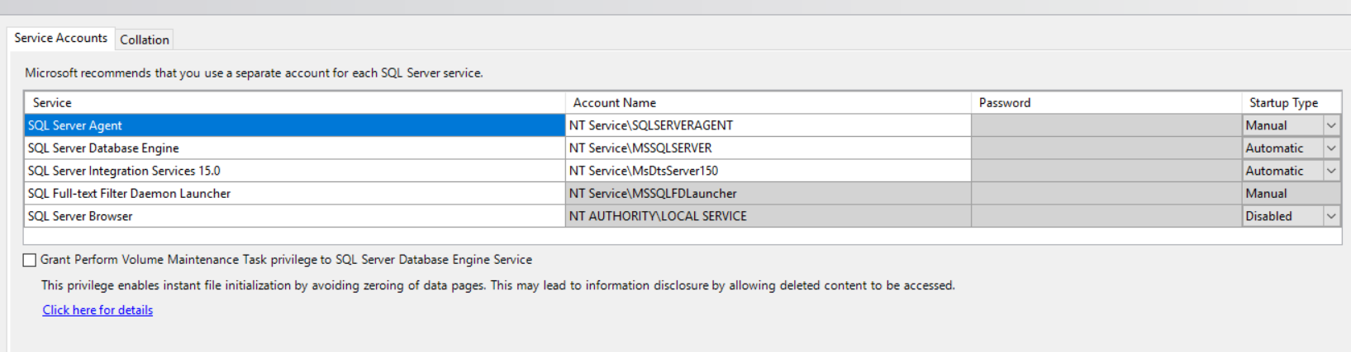

I prefer to choose Mixed mode - to have 2 users for login (so I can login to server with SA and kostiantyn.bondarenko), but you can leave just **windows mode** and press **Add current user**

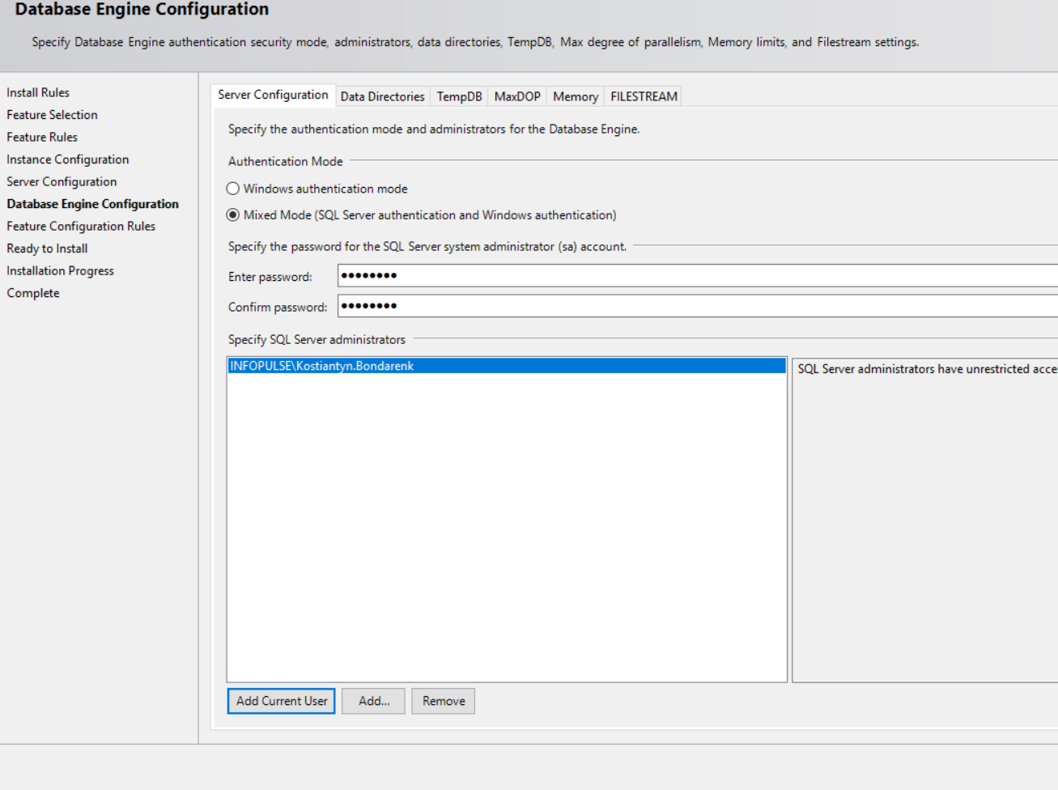

Leave as is all other tabs **C:\Program Files\Microsoft SQL Serqlver\MSSQL15.MSSQLSERVER\MSSQL\Data**

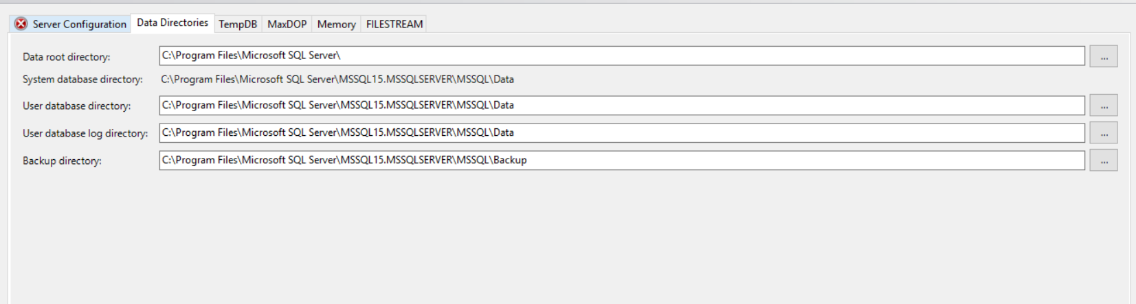

Finish and restart your PC.

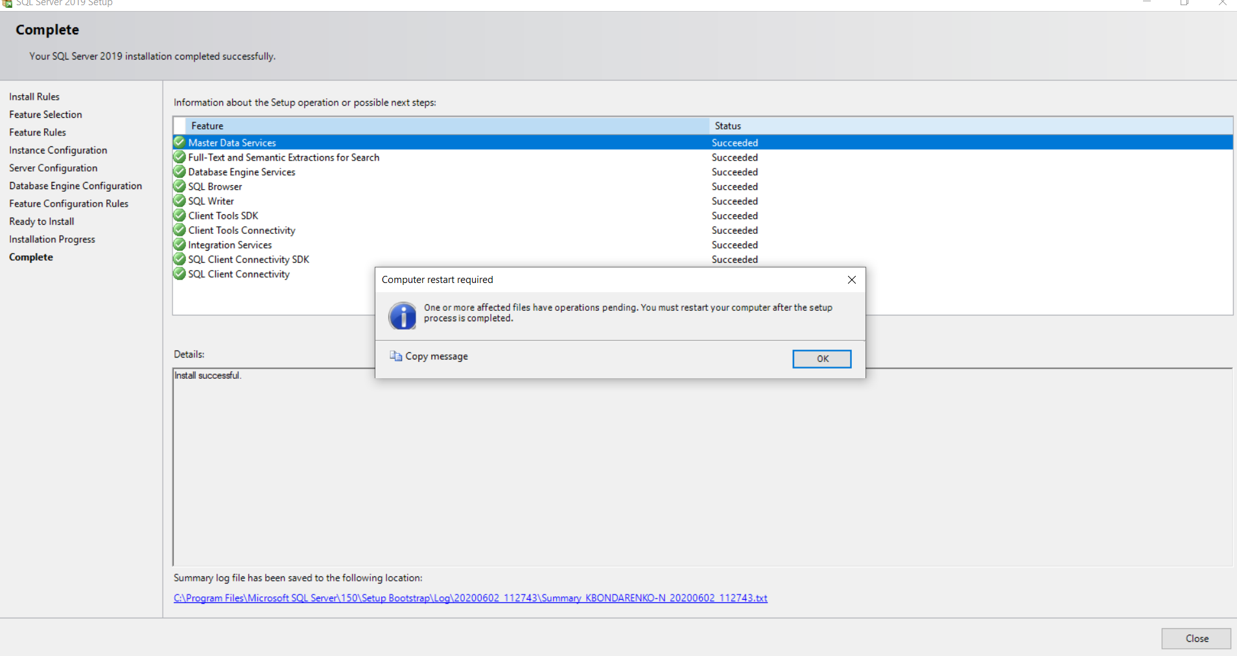

1. **SSMS (all steps by default)**

Download and install **SQL Server Management studio** - IDE for SQL development and queries(choose preferable language - English ) :

<https://docs.microsoft.com/en-us/sql/ssms/download-sql-server-management-studio-ssms?view=sql-server-ver15#available-languages>

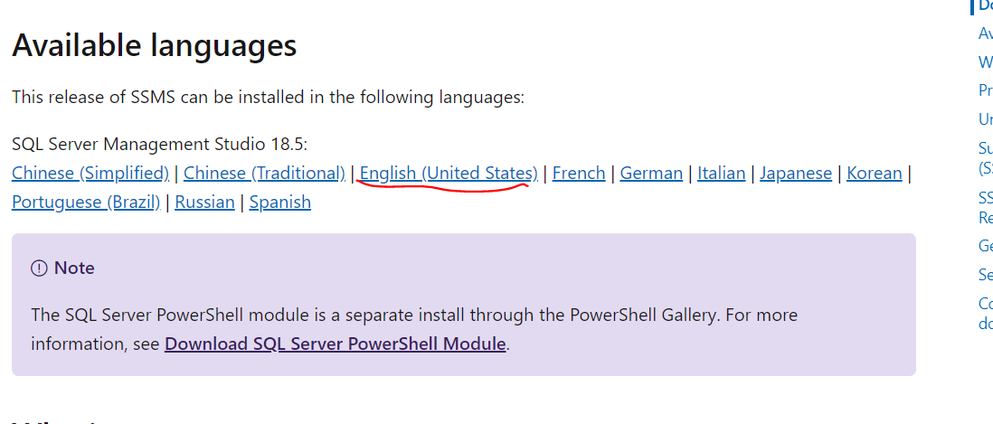

1. **SSDT – (all steps by default)**

Download and install SQL Server Data Tools (SSDT) (choose preferable language - English )- For reporting and integration services development

<https://docs.microsoft.com/ru-ru/sql/ssdt/download-sql-server-data-tools-ssdt?view=sql-server-ver15#ssdt-for-vs-2017-standalone-installer>